You as a parent and young person have the right to ask the Local Authority to reconsider the IDP if you are, or your child is:

* Dual registered e.g. might attend a pupil referral unit (PRU)
* Looked after by the LA

Then the school is required to refer the case to your LA, rather than decide for itself whether your child or you yourself, the young person has ALN.

RIGHTS TO REQUEST THAT THE LA RECONSIDERS IDP AND TAKES OVER RESPONSIBILITY FOR MAINTAINING IT, AND CONTACT DETAILS FOR THE LA





**Claire Gratton ALNCo**

**01633 647488**

**Claire.gratton@wcp.schoolsedu.org.uk**

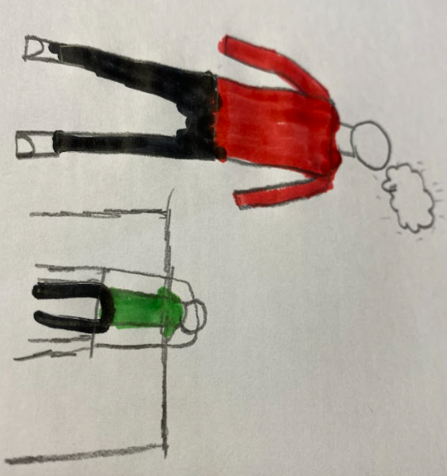

# Torfaen County Borough Council - My Council Services

Your school might refer your case or your child’s case to the LA on particular grounds which might be related to the nature of the child’s apparent ALN.

It might be that they receive some advice from a specialist service.

The school will discuss this course of action with you.

In most cases the school will make the referral within 20 school days of being informed that your son/daughter may have ALN.

When making a referral to a Local Authority, the school will inform you and your parent/s that it is doing so.

But - you as a parent and young person have the right to ask the Local Authority to reconsider the IDP if you are unhappy with the plan.

It would be best to discuss this with your/your child’s school.

Contact the head teacher or ALNCo at

< insert names contact details here>

in the first instance.

However, if you are still dissatisfied you can contact the LA directly at

Torfaen Council,

01495 766929

01495 766968

If you or your child are at school in an English LA, you can still request that the LA that maintains the school reconsiders the IDP.

You would then need to contact that LA to make the request.

